Domain Driven Design (DDD)
1. Introduction
Domain Driven Design (DDD) is an approach to software development that focuses on the core business domain and ensures that the software model reflects real business processes. It emphasizes deep collaboration between developers and domain experts to build systems that are useful, scalable, and aligned with business needs.
2. DDD Process – Key Steps (Infographic Style)
Step 1: Understand the Domain
- Collaborate with domain experts
- Identify business rules, processes, and needs
- Build a shared understanding through conversations
Step 2: Create the Ubiquitous Language
- Use a common language understood by both developers and domain experts
- Create consistent terms for entities, actions, and workflows
- Ensures clarity and reduces miscommunication
Step 3: Identify Bounded Contexts
- Break the large domain into smaller, manageable subdomains
- Each bounded context has its own logic, rules, and models
- Examples: Payments, Customer Management, Inventory, etc.
Step 4: Model the Domain (Core Modeling)
- Identify Entities, Value Objects, Aggregates, and Services
- Define relationships and rules that govern the domain
- Build domain models that accurately represent real behavior
Step 5: Define Aggregates and Aggregate Roots
- Group related domain objects
- Choose an aggregate root that controls all changes inside the group
- Ensures consistency and protects domain rules
Step 6: Implement Repositories & Domain Services
- Repositories manage data access for aggregates
- Domain services handle behavior that doesn’t belong to a specific entity
- Maintains separation of concerns
Step 7: Integrate Bounded Contexts
- Use Domain Events, APIs, or Message Queues
- Ensures different contexts communicate effectively
- Maintains clean architecture and modular growth
3. Real-World Use Case: Online Banking System (DDD Example)
Domain: Online Banking Platform
Goal: Build a secure and scalable banking application using DDD principles.

Bounded Contexts in Online Banking
- Customer Management Context
  - Handles customer onboarding, KYC details, profile updates
- Account Context
  - Manages savings accounts, current accounts, balances, statements
- Payments & Transfers Context
  - Handles NEFT, RTGS, IMPS, UPI transfers
- Card Management Context
  - Controls debit/credit card issuance, blocking, limits
- Fraud Detection Context
  - Monitors suspicious activity and anomaly detection

Domain Modeling Example
Entities
- Customer
- Account
- Transaction
- Card
Value Objects
- Money
- TransactionID
- Address
Aggregates
- Account Aggregate Root
  - Account → Transactions → Balance
Domain Services
- FundsTransferService
- FraudCheckService
Repositories
- AccountRepository
- TransactionRepository

4. How DDD Improves the Banking System
✔ Better Scalability
Each bounded context can scale independently (e.g., payments can scale separately during peak hours).
✔ Higher Security and Isolation
Sensitive domains like Fraud Detection remain isolated from other modules.
✔ Clear Communication
Ubiquitous language ensures all teams (tech + business) understand concepts like transaction, limit, verification.
✔ Easy Maintenance
Changes in one context do not break others due to clear boundaries.
✔ Real Alignment with Business Needs
Banking operations map directly to software models.

5. Visual Summary (Infographic Flow)
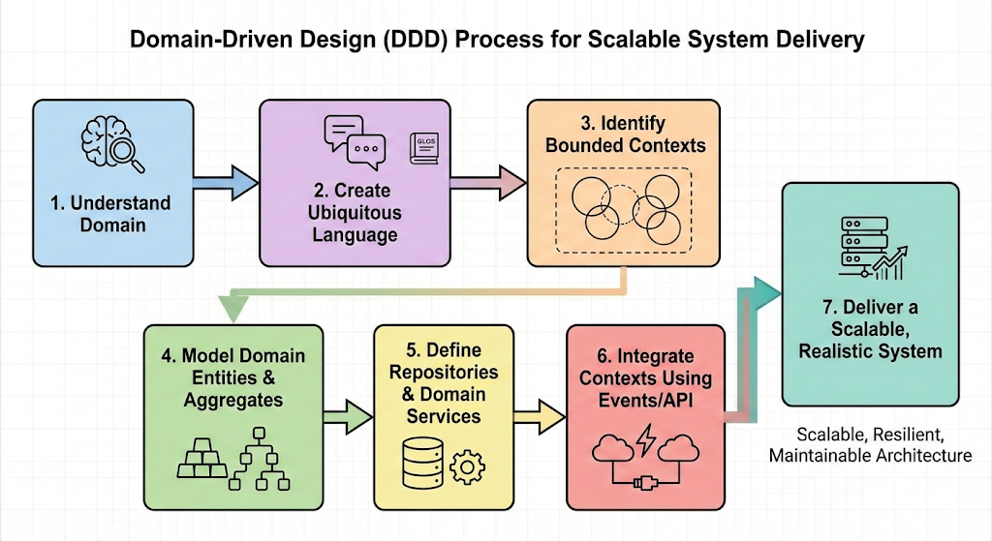
6. Conclusion
Domain Driven Design creates a strong connection between business logic and software architecture. By focusing on the domain, establishing clear boundaries, and modeling real-world behavior, DDD ensures that complex systems—especially in industries like banking—remain scalable, maintainable, and aligned with business goals.

